CP-III Project Report on

**HUMAN RESOURCE MANAGEMENT SYSTEM**

at

**U. V. Patel College of Engineering**



|  |  |
| --- | --- |
| **Internal Guide:** | **Prepared By:** |
| Prof. Chirag Gami | Mr. Vraj Patel (19012011034) |
|  | Mr. Swar Patel (19012011057) |
|  | |

**B.Tech Semester VII**

**(Computer Engineering)**

###### Nov-Dec, 2022

Submitted to,

Department of Computer Engineering

U.V. Patel College of Engineering

Ganpat University, Kherva - 384 012

##### **U.V. PATEL COLLEGE**

##### **OF**

**ENGINEERING**



**24/11/22**

**CERTIFICATE**

**TO WHOM SO EVER IT MAY CONCERN**

This is to certify that Mr. Patel Vraj Rakeshkumar student of **B.Tech. Semester VII (Computer Engineering)** has completed his/her full semester on site project work titled “**HUMAN RESOURCE MANAGEMENT SYSTEM**” satisfactorily in partial fulfillment of the requirement of Bachelor of Technology degree of Computer Engineering of Ganpat University, Kherva, Mehsana in the year 2022-2023.

|  |  |
| --- | --- |
| **Prof. Chirag Gami** | **Dr. Paresh M. Solanki** |
| **College Project Guide** | **Head, Computer Engineering** |

##### **U.V. PATEL COLLEGE**

##### **OF**

**ENGINEERING**



**24/11/22**

**CERTIFICATE**

**TO WHOM SO EVER IT MAY CONCERN**

This is to certify that Mr. Patel Swar Dineshbhai student of **B.Tech. Semester VII (Computer Engineering)** has completed his/her full semester on site project work titled “**HUMAN RESOURCE MANAGEMENT SYSTEM**” satisfactorily in partial fulfillment of the requirement of Bachelor of Technology degree of Computer Engineering of Ganpat University, Kherva, Mehsana in the year 2022-2023.

|  |  |
| --- | --- |
| **Prof. Chirag Gami** | **Dr. Paresh M. Solanki** |
| **College Project Guide** | **Head, Computer Engineering** |

**ACKNOWLEDGEMENT**

This satisfaction that successful completion of any task would be incomplete without the mention of people whose ceaseless cooperation it made it possible, whose constant guidance and encouragement crown all efforts with success. We are grateful to our guide **Prof. Chirag Gami** for the guidance, inspiration and constructive suggestions that helpful us in the preparation of this project. We also thank our colleagues who have helped in successful completion of the project.

# 

**ABSTRACT**

Employees are the backbone of any company therefore their management plays a major role in deciding the success of an organization. Employees Management Software makes it easy for the employer to keep track of all records. This software allows the administrator to edit employees, add new employees, transfer/promote/terminate employees. Each employee in the database is associated with a position can be added and edited when need arises. Employees can be transferred between positions easily without having to retype back their information in the database. You can check to see if there are duplicate positions/employees in the database. Most of all, the employer can assign tasks to employees and assess their progress in order to keep track of employee performance.

A flexible and easy to use Employee Management software solution for small and medium sized companies provides modules for personnel information management thereby organization and companies are able to manage the crucial organization asset – people. The combination of these modules into one application assures the perfect platform for re-engineering and aligning Human Resource processes along with the organizational goals. This system brings about an easy way of maintaining the details of employees working in any organization.

It is simple to understand and can be used by anyone who is not even familiar with simple employees system. It is user friendly and just asks the user to follow step by step operations by giving easy to follow options. It is fast and can perform many operations for a company.

The goal of this project is to design and develop an employee management system to fill existing gaps in the electronic management of employees.

**INDEX**

Table of Contents

INTRODUCTION 10

1.1 Purpose 10

1.2 Problem Statement 10

1.3 Overview 11

1.4 Objective 11

1.5 Tools and technology 11

FEASIBILITY STUDY 12

2.1 Study of Current System 12

2.2 Requirement of new system 12

2.3 Technical Feasibility 13

2.4 Economic Feasibility 13

2.5 Operational Feasibility 13

2.6 Requirement Validation 13

2.7 Feature of New System 13

2.8 Literature survey 14

2.9 Hardware and Software requirement 14

2.10 Project planning 15

SYSTEM REQUIRMENTS STUDY 16

3.1 Functional Requirement 16

3.2 Non-Functional requirement 17

SYSTEM DESIGN 19

4.1 Use Case 19

4.2 Class Diagram 21

4.3 Activity Diagram 22

4.4Sequence diagram 23

4.5 Dataflow diagram 24

DATABASE STRATERGY 27

5.1 Data dictionary 27

USER INTERFACE 29

CONCLUSION 33

**List of Figure**

Figure 1(EMP Usecase) 19

Figure 2(HR Usecase) 20

Figure 3(Class Diagram) 21

Figure 4(Activity Diagram) 22

Figure 5(Sequence Diagram) 23

Figure 6(DFD LEVEL0) 24

Figure 7 (DFD LEVEL1) 25

Figure 8(DFD LEVEL2) 26

**List of Table**

Table 1(Project Planning) 15

Table 2(Employee) 27

Table 3(Admin Login) 27

Table 4(Employee Leave) 27

Table 5(Project) 28

Table 6(Salary) 28

# INTRODUCTION

## 1.1 Purpose

Employees are the backbone of any company therefore their management plays a major role in deciding the success of an organization. Human Resource Management Software makes it easy for the employer to keep track of all records. This software allows the administrator to edit employees, add new employees as well as evaluate an employee’s performance. Employees can be managed efficiently without having to retype back their information in the database. You can check to see if there are duplicate positions/employees in the database.

## 1.2 Problem Statement

Manual handling of employee information poses a number of challenges. This is evident in procedures such as leave management where an employee is required to fill in a form which may take several weeks or months to be approved. The use of paper work in handling some of these processes could lead to human error, papers may end up in the wrong hands and not forgetting the fact that this is time consuming. A number of current systems lack employee self-service meaning employees are not able to access and manage their personal information directly without having to go through their HR departments or their managers. Another challenge is that multi-national companies will have all the employee information stored at the headquarters of the company making it difficult to access the employee information from remote places when needed at short notice.

The aforementioned problems can be tackled by designing and implementing a web based HR management system. This system will maintain employee information in a database by fully privacy and authority access. The project is aimed at setting up employee information system about the status of the employee, the educational background and the work experience in order to help monitor the performance and achievements of the employee through a password protected system.

## 1.3 Overview

In this system there are two modules one for all employees and another for the HR manager in that HR can manage the attendance of all employees and print out of that and manage the shift of the employees. HR can confirm leave or reject leave. Employee can check their attendance. Raise query form to HR and Employee Can Apply for Leave check leave status whether it confirm or not.

## 1.4 Objective

In this world of growing technologies everything has been computerized. With large number of work opportunities the Human workforce has increased. Thus there is a need of a system which can handle the data of such a large number of Employees. This project simplifies the task of maintaining records because of its user friendly nature.

The objective of this project is to provide a comprehensive approach towards the management of employee information. This will be done by designing and implementing an HR management system that will bring up a major paradigm shift in the way that employee information is handled.

**The objectives of this system include:**

* + - Design of a web based HR management system to fulfill requirements such as project management, leave management, report generation to assist in performance appraisal, ESS and employee trainings.
    - Well-designed database to store employee information.
    - A user friendly front-end for the user to interact with the system

## 1.5 Tools and technology

* Visual studio code
* PHP
* HTML
* CSS
* Javascript
* XAMPP Server
* DBMS software
* Visual studio code
* Windows 7

# FEASIBILITY STUDY

## 2.1 Study of Current System

The existing system is manual system. Here HR have to rake data manually. There are some companies with the software of HR management. They Provide very expensive services so that small companies does not afford the HR software. And In the small companies have to track all employee data in books. And employees have to fill manually form for the leave. And HR have manage all the things manually.

## 2.2 Requirement of new system

Employees are the backbone of any company therefore their management plays a major role in deciding the success of an organization. Human Resource Management Software makes it easy for the employer to keep track of all records. This software allows the administrator to edit employees, add new employees as well as evaluate an employee’s performance. Employees can be managed efficiently without having to retype back their information in the database. You can check to see if there are duplicate positions/employees in the database.

A flexible and easy to use Employee Management software solution for small and medium sized companies provides modules for personnel information management thereby organization and companies are able to manage the crucial organization asset – people. The combination of these modules into one application assures the perfect platform for re-engineering and aligning Human Resource processes along with the organizational goals. This system brings about an easy way of maintaining the details of employees working in any organization.

It is simple to understand and can be used by anyone who is not even familiar with simple employees system. It is user friendly and just asks the user to follow step by step operations by giving easy to follow options. It is fast and can perform many operations for a company.

## 2.3 Technical Feasibility

The current system developed is technically feasible. It is web based user interface.It provides easy interface to users. The software and hard requirements for the development of this project are not many and are already available as a free open source.

## 2.4 Economic Feasibility

The project has shown the economic feasibility by the study of the fact that by using this software the increased number of the consumers can be given service effectively and efficiently and can save a lot time and saving time means saving money. The cost and benefit analysis has shown that cost that have incurred in developing the project is less than the benefits that the project is going to provide once it is developed, so this project has passed the feasibility test.

## 2.5 Operational Feasibility

The proposed system is operationally feasible. It provides sufficient support from management to the users. System will be used and work properly if it being developed. There is no resistance from user side.

## 2.6 Requirement Validation

* Any web browser like chrome, internet explorer etc. to run the site.
* For user login they have to registerd with the HR manager and HR will add the employee in the system and after that admin gives login id and password to the employee after that employee can change the password of their login.
* HR need to login by special id and password.

## 2.7 Feature of New System

The proposed system is designed to eliminate all the drawbacks of the existing employee management software. The system shall be responsible for maintaining information about employees, thus their personal profile. The system shall incorporate leave management all the way from application to acceptance/rejection of leave requests as well as all employee projects with close monitoring of the projects from creation to completion and trainings to assist in monitoring active and inactive employees.

The main features to be added include:

* Employee profiles
* Leave management
* Task management
* Trainings
* Projects (Work Breakdown Structure)
* Notifications
* Employee Self-Service (ESS)

## 2.8 Literature survey

* 1000projects.org
* [www.ofnisystems.com](http://www.ofnisystems.com)
* Google for queries

## 2.9 Hardware and Software requirement

1. **Hardware requirement**

EMS should be able to work on a computer with the following minimum hardware specifications:

OS: Windows XP/Vista/7/8/10/11

CPU: Pentium III (700MHz) and above Memory: 128 MB and above

Capacity: 4GB of hard drive

Others: Network interface card, mouse, keyboard, and monitor.

1. **software requirement**

Since HR system application is a web-based application, internet connection must be established. The EMS software personal database model will support MySQL environment as DBMS.

## 2.10 Project planning

|  |  |  |  |  |  |
| --- | --- | --- | --- | --- | --- |
|  | **1st Week** | **2nd Week** | **3rd Week** | **4th Week** | **5th Week** |
| 1st  Month | Study of PHP | Study of Database | Get overview of project | Made database based on the analysis |  |
| 2nd  Month | Draw DFD and ER diagram | Start coding about some basic programming | Coding | Coding |  |
| 3rd  Month | Coding | Coding | Coding | Coding | Coding |
| 4th  Month | Testing and Integrating modules, implementation | Preparation of documentation | Give final touch up to documentation |  |  |

Table 1(Project Planning)

# SYSTEM REQUIRMENTS STUDY

## 3.1 Functional Requirement

**Authentication**

* Login- The user can login to the HRMS system with his/her username and password.
* Logout- The user can log out from the HRMS system.

Login failure- If the user does not exist in the database or the user has not yet being authorized by the HRMS admin.

**Authorization**

* User role check- After logging in, the user role will be checked from the database and the user interface will be displayed according to their role.

**Process Data**

* Display- User with defined roles can display the content of the database. Being more specific, employee can only view his/her personal information. HOD can not only see his/her personal information but also employee’s information who are under his/her department or school. Admin and HR can display their personal information and all employees’ information.
* Edit- A user with employee role can edit his/her specific personal information. Dean or HOD can only edit employees’ personal information that is under his/her coverage except user role type. Admin can edit all information related to all employees’ including their user role type.
* Search- User with Dean/HOD role can search the content of database for the employees’ who are under his/her coverage. HR and admin roles can search all the employees’ information in the database. Search feature works on specific keywords showing employee’s characteristics, peculiarities, skills, features, and etc. For example, HR wants to find employees’ who are well trained in “Java Programming Language”. He/she will write the specific keyword in the search bar and press the available search button. Afterwards, he/she will find a list of all the employees’ who know “Java Programming”. Update authentication- This feature can be used only by admin role type. Admin can update the role type of a specific user. For example, an employee got promotion and his role type will be changed from employee role id to HOD or Dean role. Admin will be able to update this authentication mechanism.

**Leave Application/Approval**

* Leave application- The user can be able to fill in leave application form in the appropriate fields.
* Leave approval- The admin can be able to approve leave applications based on the reasons stated, length of leave as well as available HR on a department.

Leave days accrued- The user shall be able to check the number of leave days accrued.

**Recruitment**

* Add new employee- HR role type is able to add a new employee to the database. The new employee will have all the required personal information related to him/her. The new created employee will have an id.
* Add a new user- After a new employee has being created by HR role, admin role is responsible for creating a new user by the specified id assigned in the “Add a new employee” feature. The unique id will be given by the system. Admin will assign a new role such as employee, Dean, HOD, HR, and admin to the new created user.

**Report generation**

* Report generation- HR shall be able to generate a report in pdf format for each employee based on the information in the database.

**Project Management**

* Create project team: The HOD of department or project manager shall be able to create a project and come up with a project team.
* Work Breakdown Structure (WBS): The HOD or project manager shall be able to assign tasks to the project team as well as monitor their progress.

**Trainings and Task Management**

* Trainings: The HOD shall create trainings and assign employees that are required to attend the trainings as well.
* Tasks: HOD shall assign tasks to employees in his/her department

## 3.2 Non-Functional requirement

**Performance requirements**

There is no restriction on the number of the users to be added to the database.

**Hardware requirements**

HR System should be able to work on a computer with the following minimum hardware specifications:

OS: Windows XP/Vista/7/8/10/11

CPU: Pentium III (700MHz) and above Memory: 128 MB and above

Capacity: 4GB of hard drive

Others: Network interface card, mouse, keyboard, and monitor.

**Software requirements**

* Since HR system application is a web-based application, internet connection must be established. The HR software personal database model will support MySQL environment as DBMS.

# SYSTEM DESIGN

## 4.1 Use Case

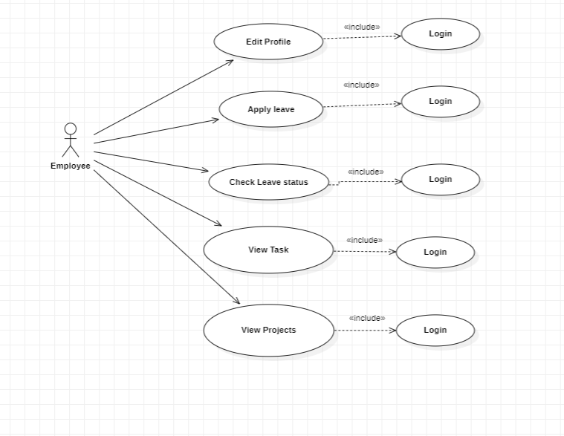

Figure 1(EMP Usecase)

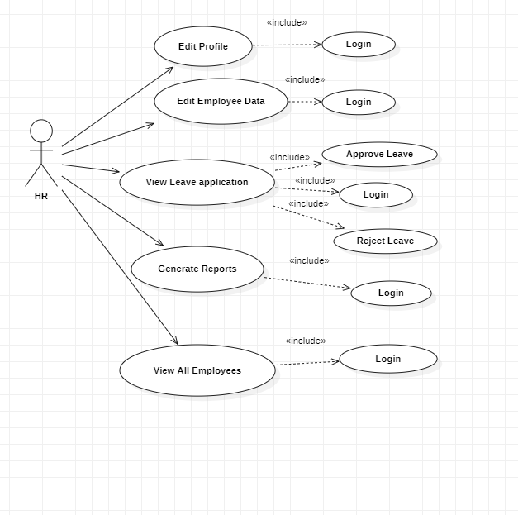

Figure 2(HR Usecase)

## 4.2 Class Diagram

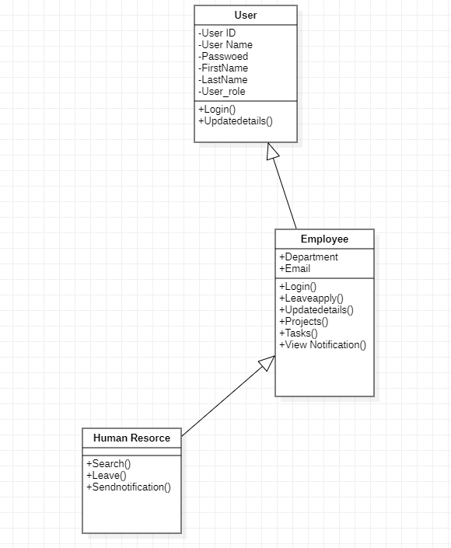

Figure (Class Diagram)

## 4.3 Activity Diagram

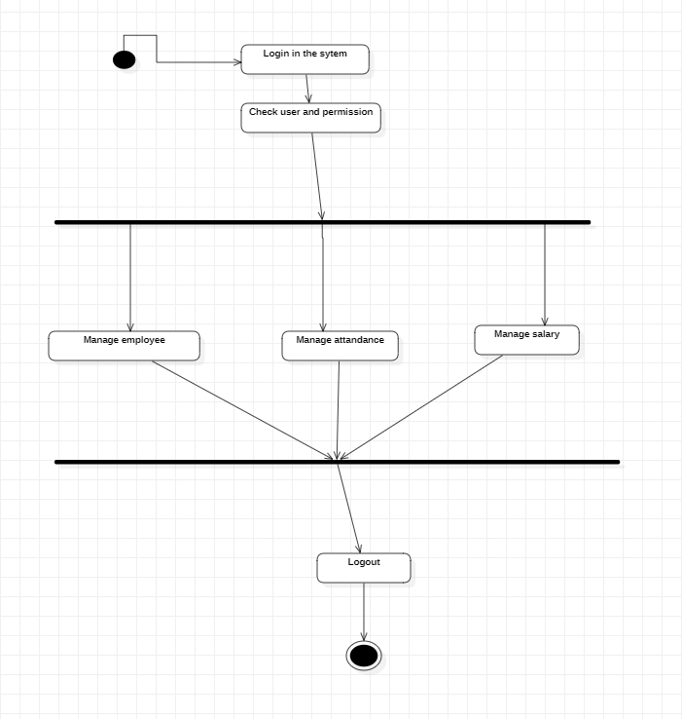

Figure 4(Activity Diagram)

## 4.4Sequence diagram

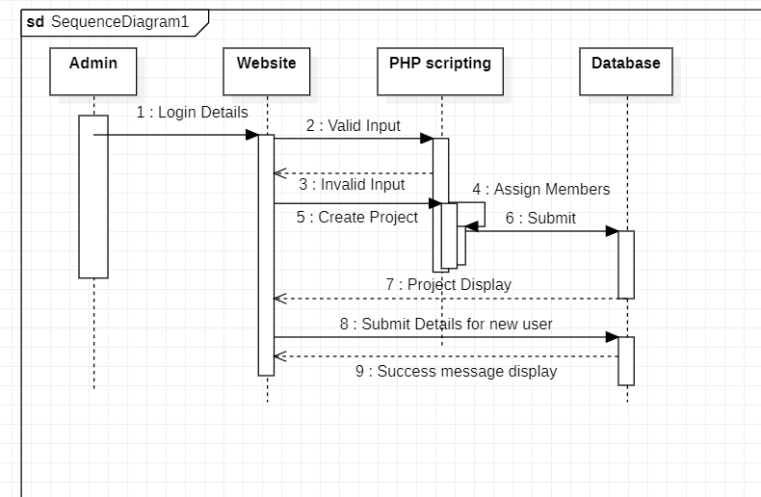

Figure 5(Sequence Diagram)

## 4.5 Dataflow diagram

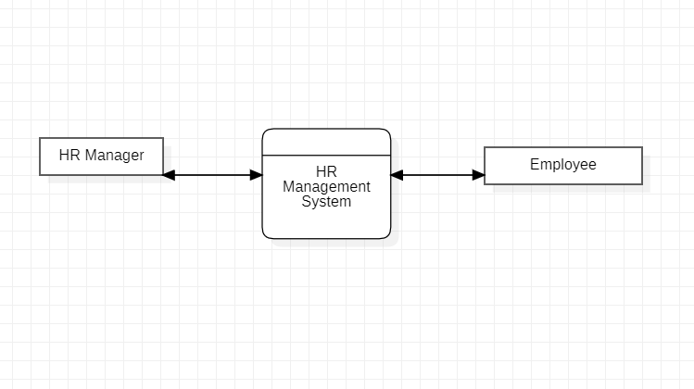

Figure 6(DFD LEVEL0)

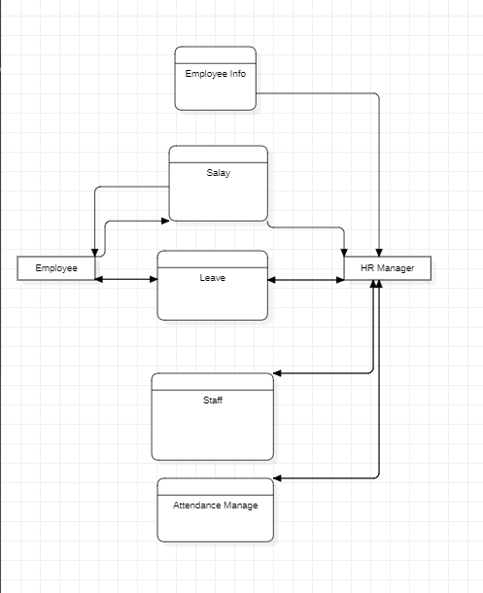

Figure 7 (DFD LEVEL1)

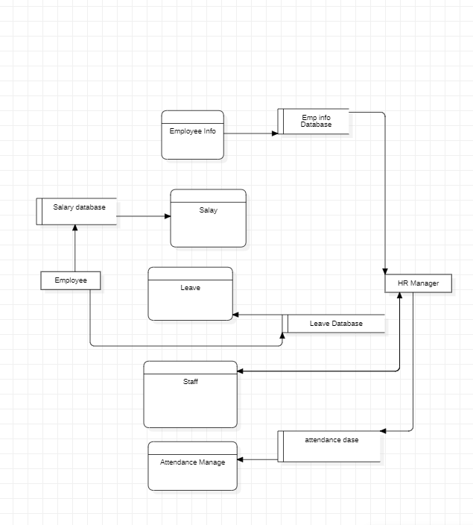

Figure 8(DFD LEVEL2)

# DATABASE STRATERGY

## 5.1 Data dictionary

|  |  |  |
| --- | --- | --- |
| Column | Type | Null |
| EMP ID | Int | No |
| NAME | Varchar(50) | No |
| EMAIL | Varchar(50) | No |
| PHONENO | Int(10) | No |
| ADDRESS | Varchar(255) | No |
| PASSWORD | Varchar(50) | No |
| DEPARTMENT | Varchar(50) | No |
| Birthdate | Date | No |
| PROFILE PHOTO | Images | Yes |

Table 2(Employee)

|  |  |  |
| --- | --- | --- |
| Column | Type | Null |
| ID | Int | No |
| PASSWORD | Varchar(50) | No |

Table 3(Admin Login)

|  |  |  |
| --- | --- | --- |
| Column | Type | Null |
| EMP ID | Int | No |
| TOKEN | Int | No |
| REASON | Varchar(50) | No |
| START | Date | No |
| END | Date | No |

Table 4(Employee Leave)

|  |  |  |
| --- | --- | --- |
| Column | Type | Null |
| PROJECT ID | Int | No |
| EMPLOYEE ID | Int | No |
| PROJECT NAME | Varchar(50) | No |
| DUEDATE | Date | No |
| SUBMISSION | Date | No |
| MARK | Int | No |
| STATUS | Varchar(50) | No |

Table 5(Project)

|  |  |  |
| --- | --- | --- |
| Column | Type | Null |
| EMPLOYEE ID | Int | No |
| BASE | Int | No |
| BONUS | Int | No |
| TOTAL | Int | No |

**Table 6(Salary)**

# USER INTERFACE

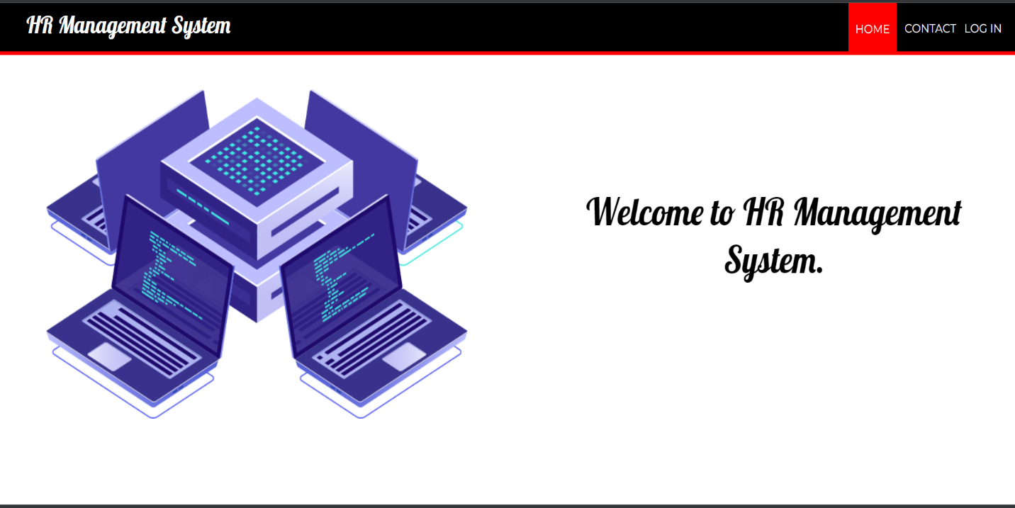

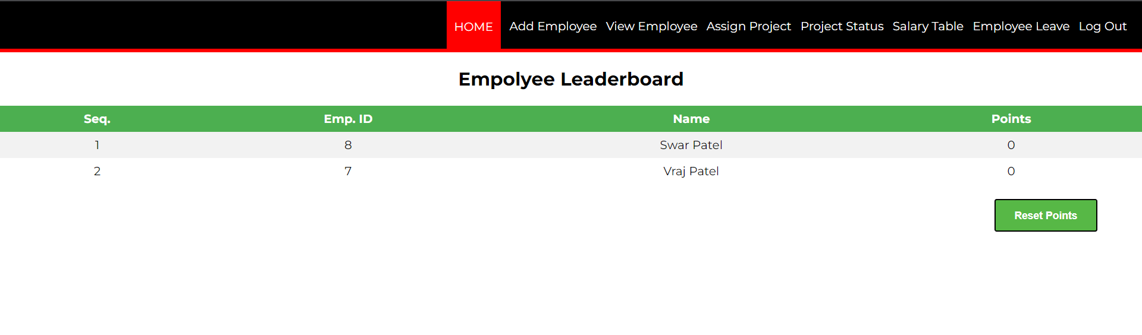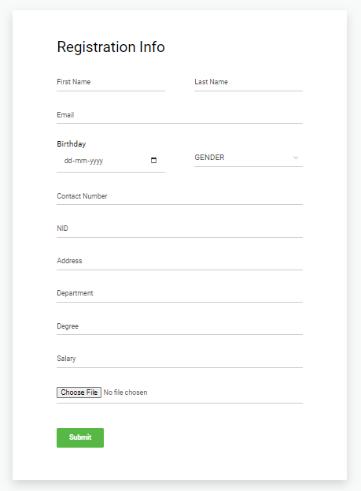

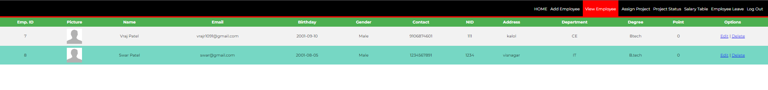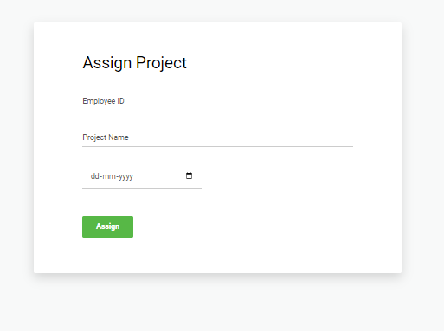



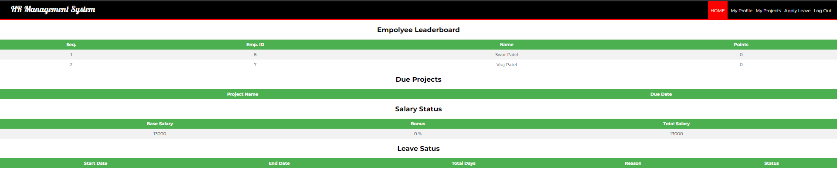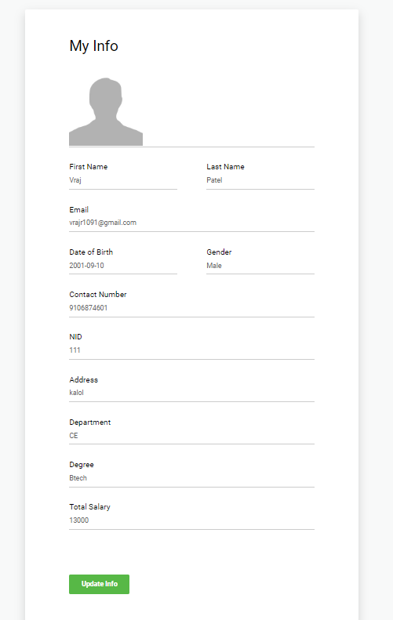

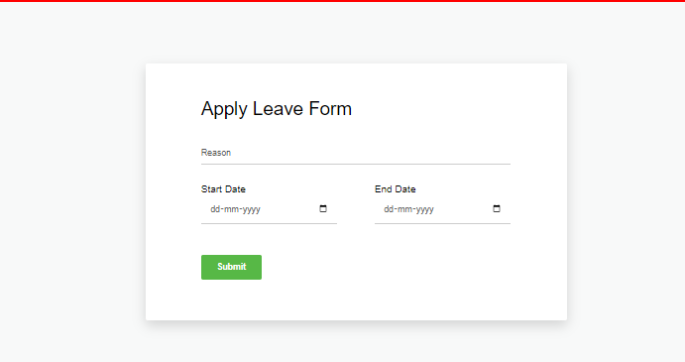

# CONCLUSION

In this chapter, the results were discussed, problems faced and limitations were elaborated. Future recommendations for the extension and improvement of the system have also been discussed as well as well as an assessment of achieved functionality.